VAMT 11/12: ANDY WARHOL STYLE TUTORIAL

Step 1
Open Photoshop; then open any portrait image to create Andy Warhol effect.
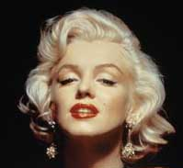

Step 2
Duplicate layer. On duplicated layer, select background and delete it.
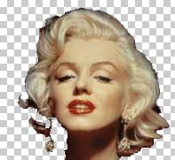

Step 3
Go to Image -> Adjustments -> Threshold (Threshold Level 135).
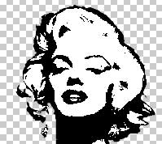

Step 4
Fill background with colour of your choice.

Step 5
Copy and paste each part of the head into a new layer and change the colors.
